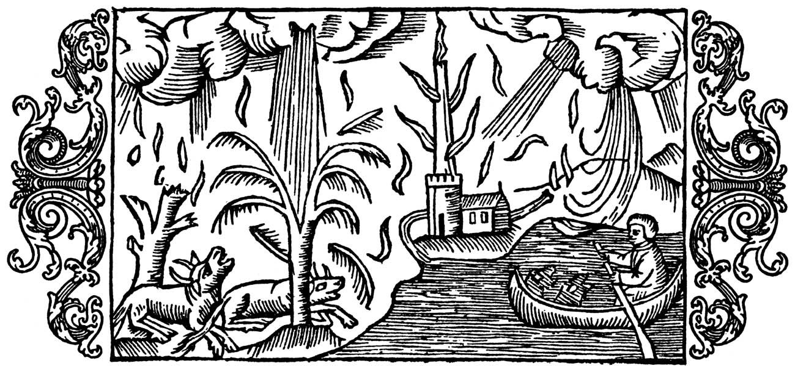

Nightjar: About the Book
A fantasy, folkloric novel set in the broader genre of speculative fiction, Nightjar is a simple tale. At its core it explores the length that one being will go to for eternal love.
In a future world, two boys escape strict boundaries to embark on an adventure. On an old Roman Road they meet with a magickal creature tormented and driven by love, the simplest of motives.
This is:
Nightjar...
Through him they will discover the existence of ancient power and beings the world does not fully appreciate or understand.
As a search party hurries to rescue the boys, so the tale touches on and explores other themes. These include belief, status, health, birth, death and the destruction of an old land and society (the present) that has given rise to a superstitious, corrupt and more feudal way of life.
With inspiration provided by the Greensand Ridge in Bedfordshire, Nightjar draws on a backdrop of nature, the rising of the sea, and the site of an old Roman and Iron Age fort in the midst of ancient woodland (Caesar’s Hill).

